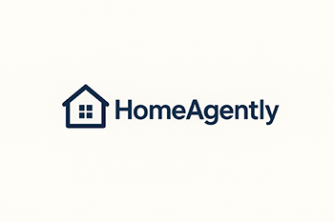
Personal Information Request Form
In accordance with applicable U.S. privacy laws, and depending on the jurisdiction in which you reside, you may be able to exercise certain data rights regarding your personal information. Please complete this form to submit your request. In some cases, we may require additional information if we are unable to verify your request based on the information you have provided.
For more information on how HomeAgently handles personal information and how our verification process works, please review our Privacy Policy found here.

Q1: Do you have an account with us?
- Yes – I have an account with HomeAgently. My username is
- No – I do not have an account with HomeAgently.
Q2: Below is my relationship with HomeAgently (please check all that apply):
- I am a buyer with HomeAgently.
- I am a seller with HomeAgently.
- I am an agent with HomeAgently.
- I am an iBuyer with HomeAgently.
- I have applied for a HomeAgently estimate.
- I have applied for a HomeAgently Home Loan.
- I am an employee, owner, director, officer, or contractor of a company which does business with HomeAgently.
- I am an employee, contractor or job applicant at or for HomeAgently (current or former).
- I participate/have participated in HomeAgently marketing activities such as surveys, polls, contests, and promotions.
- I am a website visitor.
- No relationship.
- Other (please specify):

Q4: Please tell us more about yourself so we can properly identify you.
First Name:
Last Name:
Telephone No.:
[Home address: ]
Email:
Q5: Are you making a request regarding your own personal information or on behalf of someone else for their personal information (for example, an authorized agent or parent/guardian)?
- I am submitting a request regarding my own personal information. Skip to Q8.
- I am submitting a request on behalf of someone else.
Q6: Who is the individual for whom you are making this request? Please provide us with the information below:
First Name:
Last Name:
Telephone No.:
[Home address: ]
Email:
Q7: What is your relationship to the individual?
- I am their Authorized Agent.
- Neither of the above.
Note: To verify that you are an Authorized Agent, we may contact you for additional information.
Q8: What is your request? (check all that apply)
- Opt-out of the “sale” of my personal information.
- Delete my personal information.
- Access my personal information.
- Know the categories of personal information collected about me.
- Correct my personal information.

CONSENT: By submitting this form, I certify that the information I have provided is true and accurate. I understand that falsifying information could lead to an improper release of another individual’s personal information. I authorize HomeAgently to contact me if additional information is needed to verify my request.
Name: [type name]
Date: [select date]

